FAST AI

While using Fastbook on a local computer.
- Use the conda - python version 3.10.12 that fastai tells you to install

Hackers guide to LLMS:
- nat.dev

1. Lesson -1
Paperspace || Kaggle || Colab
ALL HAVE ITS ADVANTAGE
--> Pretrained Ai Models
--> Model Zoo

2. Lesson -2
37:00 - Deploying your deep learning model – Hugging Face Spaces + Gradio

Streamlit-Instead of Gradio
https://youtu.be/F4tvM4Vb3A0?list=PLfYUBJiXbdtSvpQjSnJJ_PmDQB_VyT5iU&t=3705

Github Pages- To host the webpage

3. Lesson -3
a. @interact
→ Use “silders” to change the visualization graph
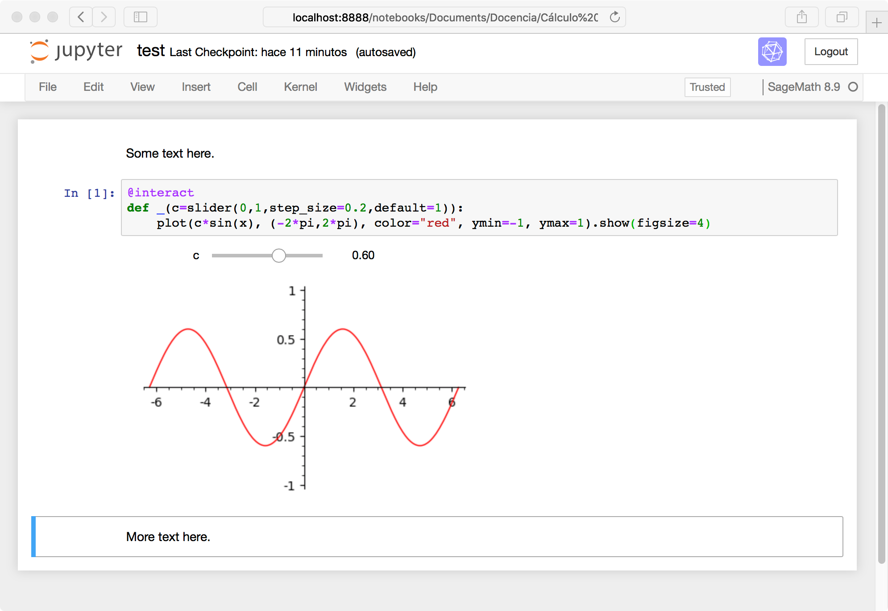
b. partial function
→ If a function has 3 parameters
→ We can fix 1 or 2 parameters
→ Vary only 1/2 parameter

4. Lesson -4

Python for Data Analysis, 3E – Wes Mckinney
https://wesmckinney.com/book/

